9. Implement a Basic Reinforcement Learning Model (Q- Learning)

Aim:
To implement a basic Reinforcement Learning model using the Q-Learning algorithm to learn the optimal actions for an agent in an environment.

Algorithm:
- Start the program.
- Import the required libraries, NumPy and Random.
- Define the environment, states, actions, and rewards.
- Initialize the Q-table with zeros.
- Select an action using the epsilon-greedy strategy.
- Perform the action and observe the reward and next state.
- Update the Q-table using the Q-Learning formula.
- Repeat the process for multiple episodes until the agent learns the optimal policy.
- Display the updated Q-table and learned policy.
- Stop the program.

CODE AND OUTPUT:

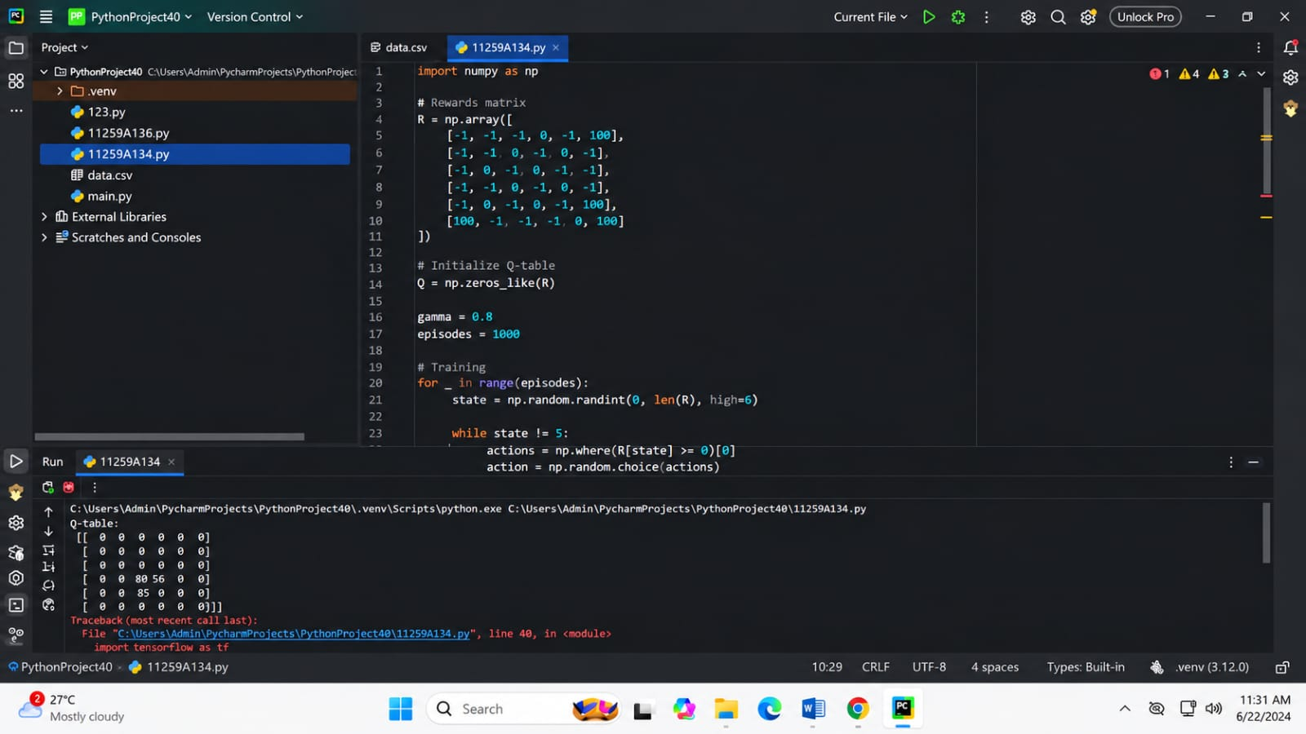

Result:
Thus, the basic Reinforcement Learning model using Q-Learning was successfully implemented, and the agent learned the optimal actions based on the rewards received from the environment.

